

Luxe Hotel Reservation

Group 5

Names : Fia Valentina Setiono (2120010048)

Gendis Putri Ayu Larasati (2120010054)

Class : 2WD2

CEP CCIT

FAKULTAS TEKNIK UNIVERSITAS INDONESIA

2022

**Developed by**

1. **Fia Valentina Setiono**
2. **Gendis Putri Ayu Larasati**



**PROJECT ON**

*Luxe Hotel Reservation*

**Luxe Hotel Reservation**

Batch Code : 2WD2

Start Date : Friday, 21 July 2022  
End Date : Thursday, 27 July 2022

Name of Faculty : Riza Muhammad Nurman

Names of Developer :

1. Fia Valentina Setiono
2. Gendis Putri Ayu Larasati

Date of Submission : Thursday, 28 July 2022

**CERTIFICATE**

This is to certify that this report titled “Luxe Hotel Reservation” embodies the original work done by Fia Valentina Setiono and Gendis Putri Ayu Larasati. Project in partial fulfillment of their course requirement at NIIT.

Coordinator:

Riza Muhammad Nurman



**ACKNOWLEDGEMENT**

Authors would like to praise to Allah, Most Merciful bless and so authors can finish this project, with entitle “Luxe Hotel Reservation”. Author would like to thanks to Mr. Riza Muhammad Nurman as lecturer who has given usefull suggestion which are help authors in writing this paper.

The author realizes that this paper is still far from perfect, so the author will be very appreciative and enthusiastic, if colleagues and supervisors who have been deigned to provide suggestions and criticisms for this paper.

**SYSTEM ANALYSIS**

**System Summary**:

Luxe Hotel is a 4-star hotel that stands majestically in the center of Bogor City. Luxe Hotel Bogor is the second hotel under the Moon Light Hotel Group and has been open since February 18, 2018.

In this project, users can search for all information, such as hotel descriptions, and the room types. this is why a good hotel reservation system is needed to make this task as easy as possible. This paper shows how the noted complicated human task can be solved by using a database Management System together with scripting and programming languages like HTML respectively as the key tools in the development of a Luxe Hotel System.

**HARDWARE AND SOFTWARE REQUIREMENTS**

Hardware: Personal computer, intel core i5

Operating System: Microsoft Windows 10 Pro 64-bit

Software: Apache Netbeans, Apache Tomcat, XAMPP, MS Word, MS PowerPoint

\

sssssssssss

**ACTIVITIES LIST**

|  |  |  |
| --- | --- | --- |
| **No** | **Date** | **The Progress** |
| 1. | July 21, 2022 | Design the Concept |
| 2. | July 21, 2022 | Disscuss website Content |
| 3. | July 24, 2022 | Start making web syntax |
| 4. | July 24, 2022 | Create web syntax |
| 5. | July 27, 2022 | Create paper |
| 6. | July 27, 2022 | Create web syntax, consul, and complete paper |
| 7. | July 27, 2022 | Create PowerPoint and record video |

**TECHNOLOGY DIAGRAM**

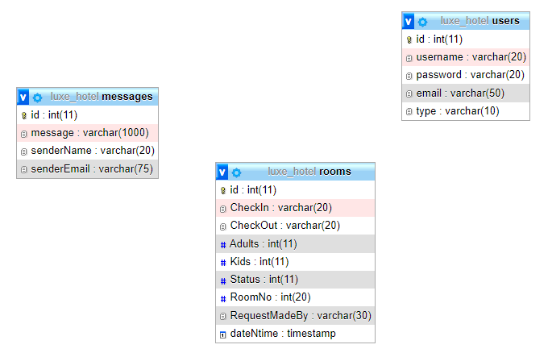

**JSP PAGES**

* Login

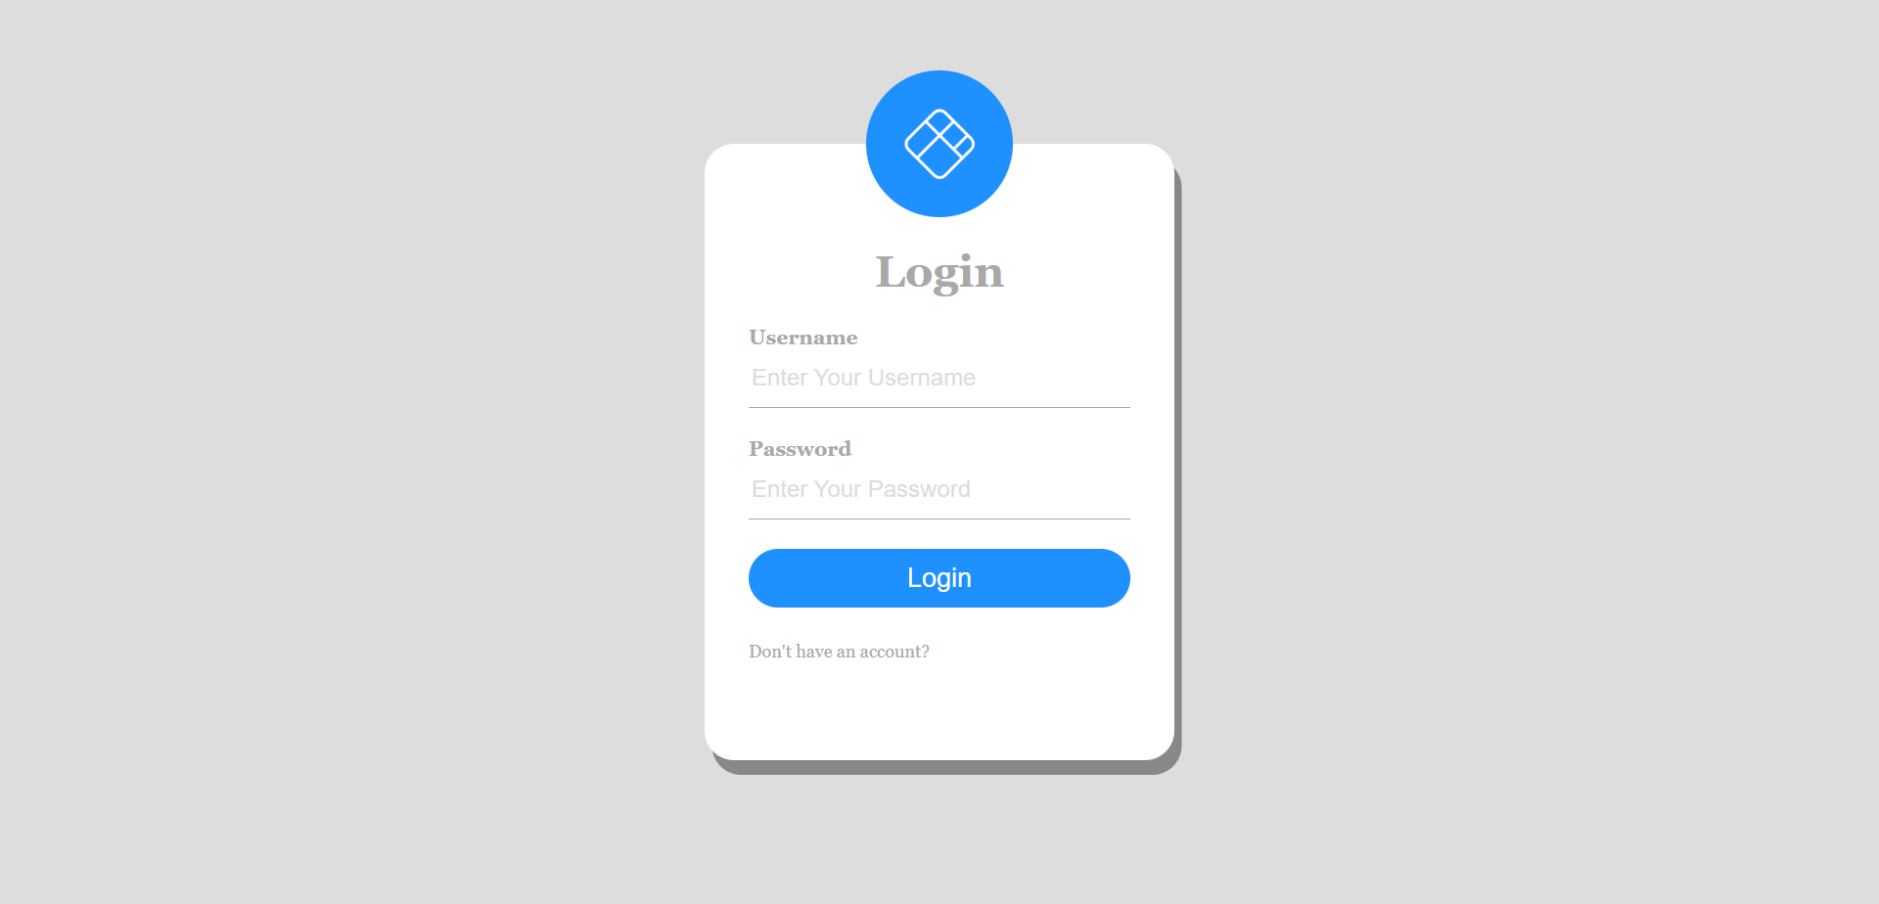

In this form, we can login as a user or as owner.

* Sign Up

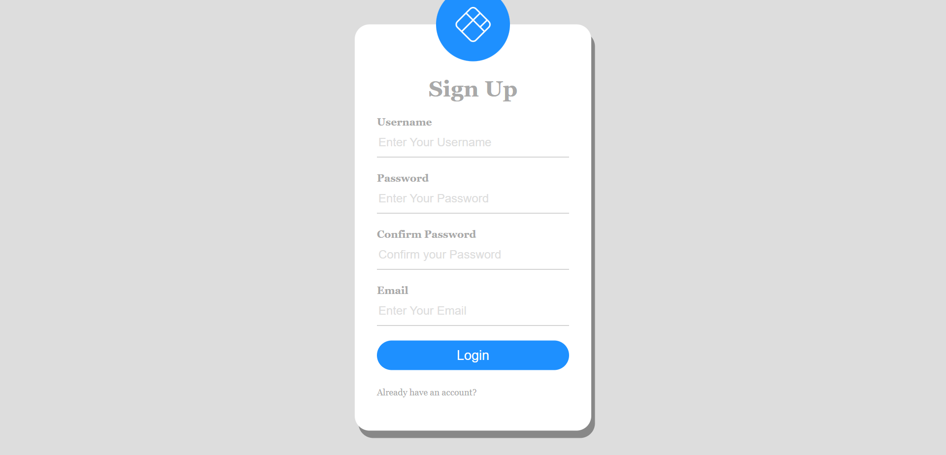

In this form, user can make a account for register.

**JSP PAGES**

* User Request

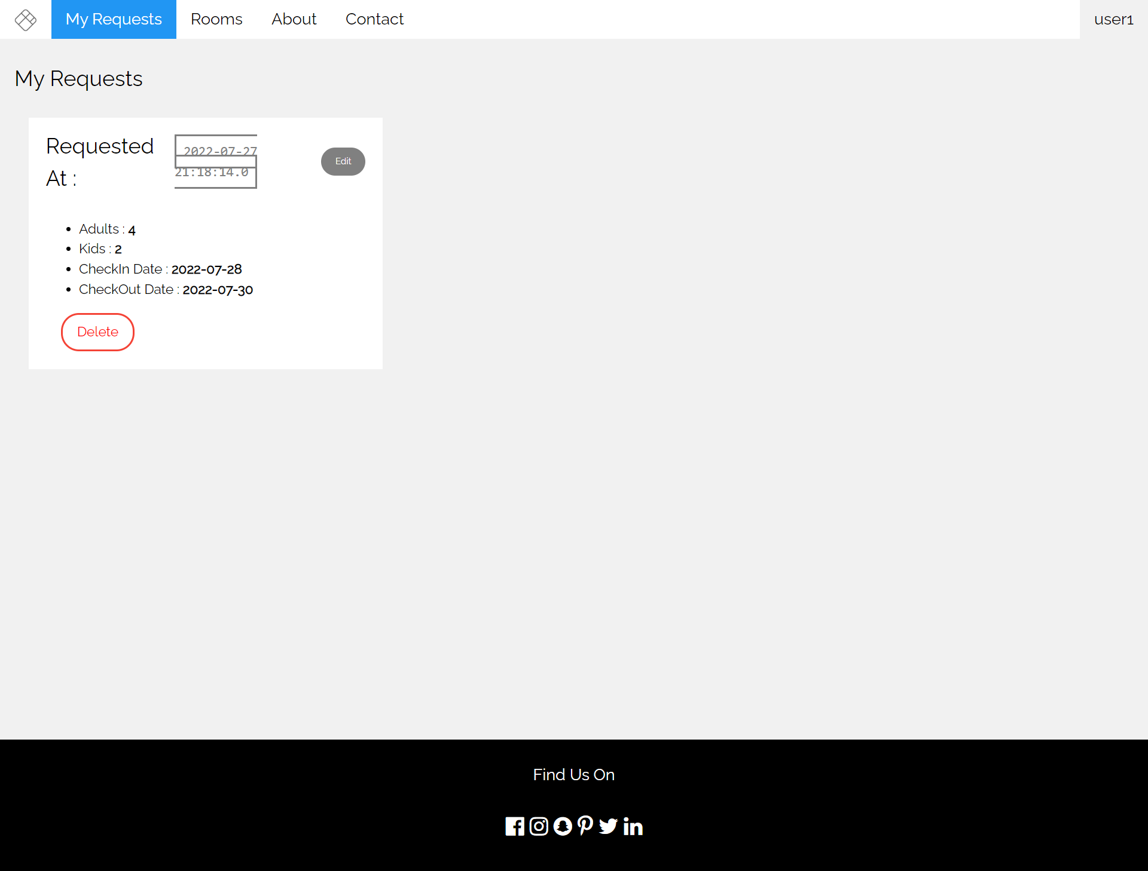

In here User can see the input of the data and check whether the room has been confirmed or not.

* Rooms

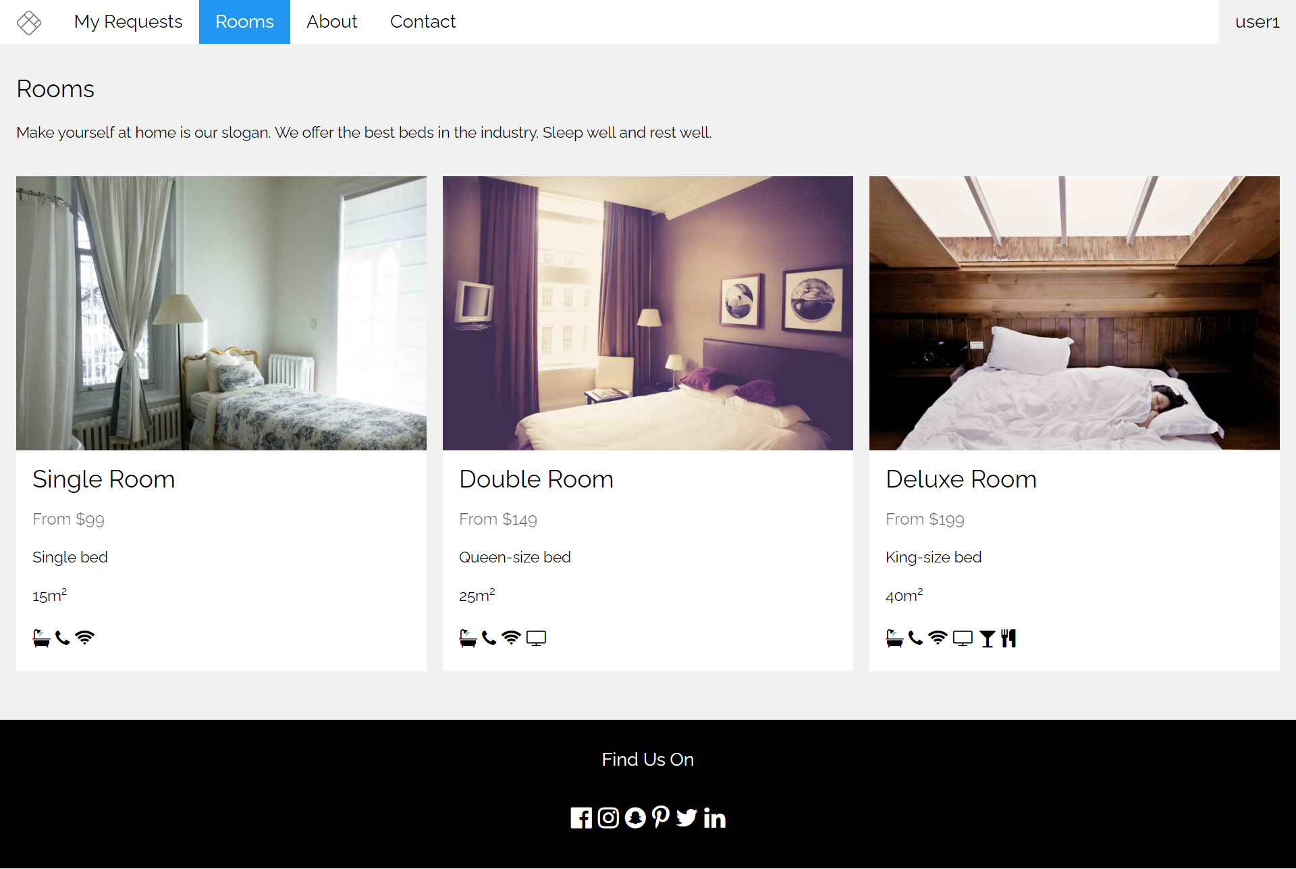

This page contains the room types.

**JSP PAGES**

* Owner Home

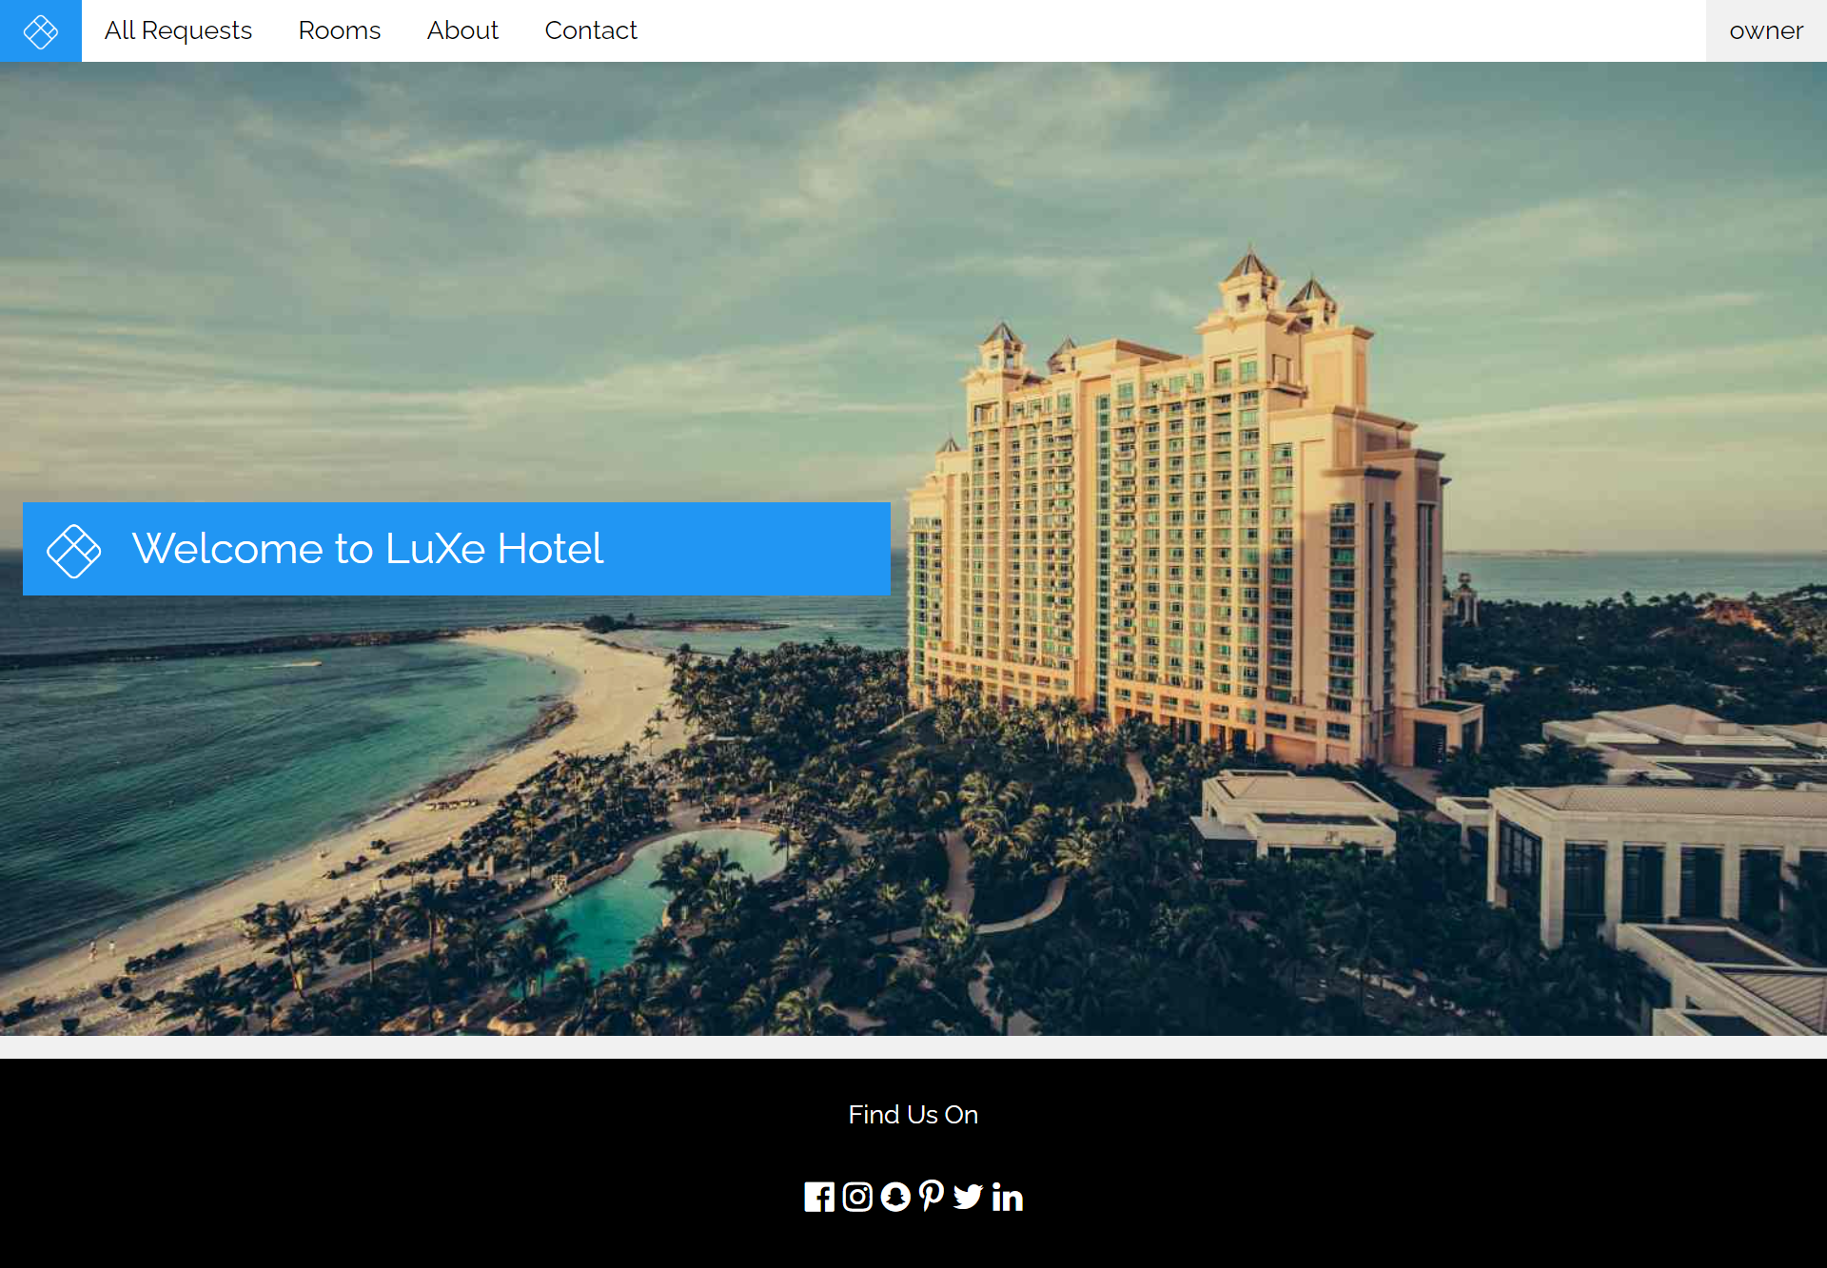

This is the home page from the owner section.

* Owner Accept

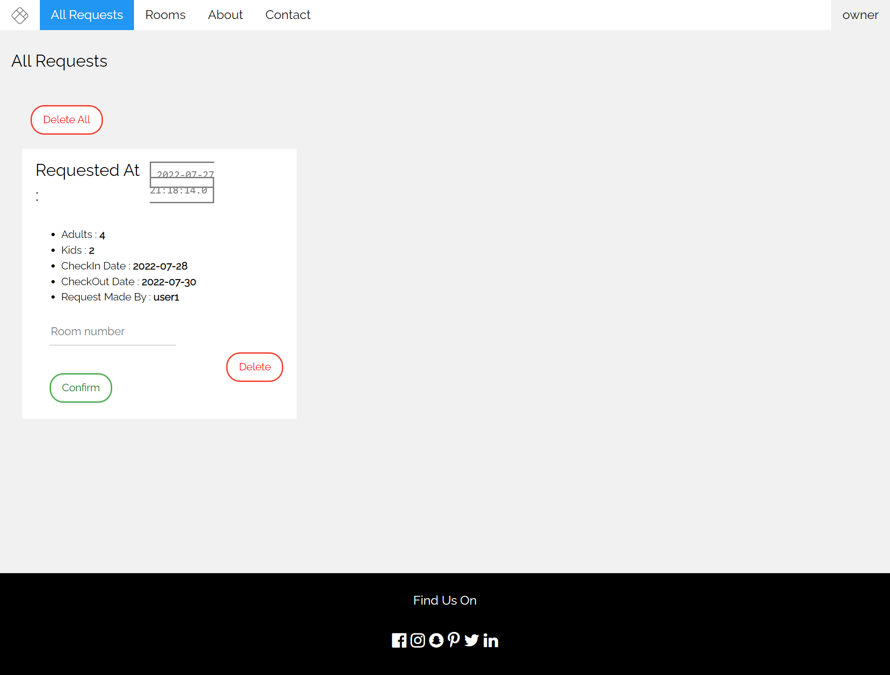

It Contains the data from the owner section, the owner can confirm the reservation from user.

**CONFIGURATION**

Hardware : Intel Core i5 8250U

Operating System : Windows 11 Home Single Language

Software : Microsoft Word, Microsoft Power Point, Adobe Photoshop CS6, Visual

Studio Code.

|  |  |  |
| --- | --- | --- |
| **Project File Details** | | |
| **S.No** | **File Name** | **Remarks** |
| 1. | Project 6 – LUXE HOTEL RESERVATION.docx | Documents |
| 2. | Project 6 – Luxe Hotel.pptx | Power Point |
| 3. | Luxe Hotel – Group 6.zip | Folder |